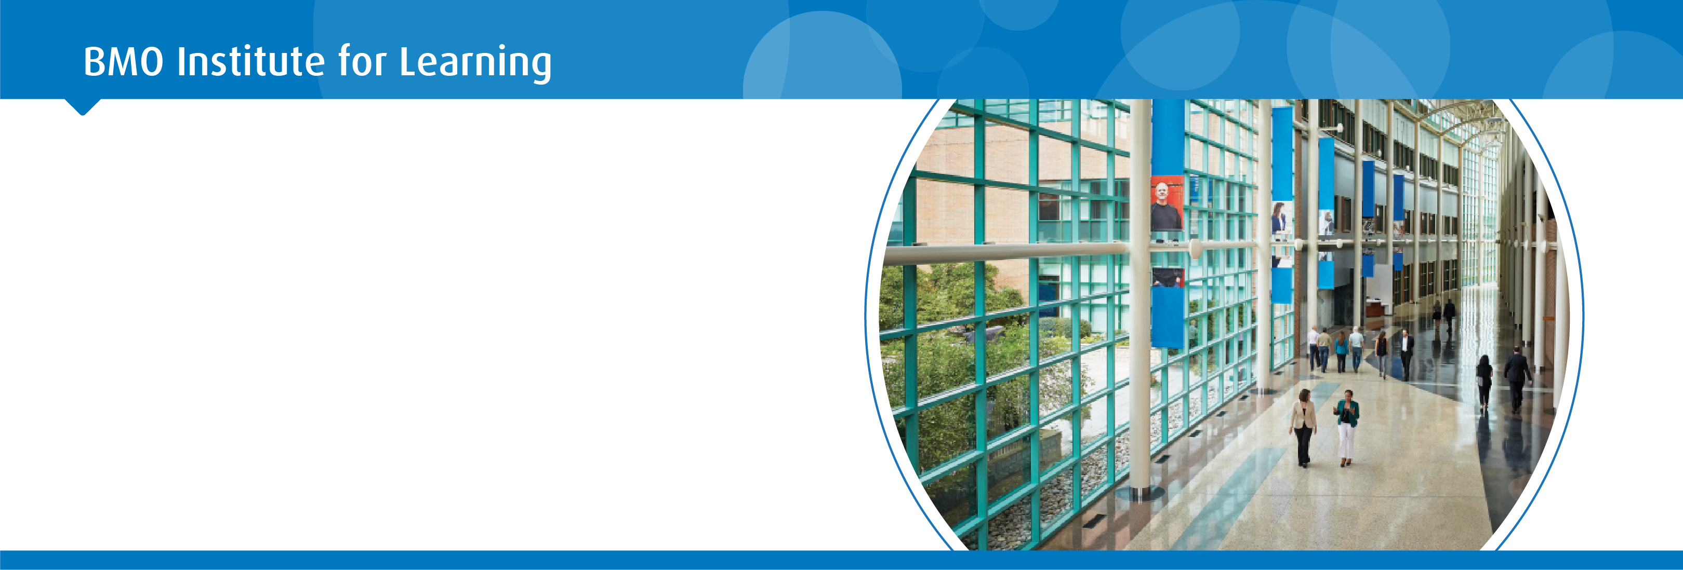

Reservation Request Form

BMO Financial Group Institute for learning

Innovators Alliance

Thursday October 10, 2019 to Friday October 11, 2019

Weekday - Bed & Breakfast Rate @$215.00 per person, single occupancy, per night + taxes

Rooms will be reserved at the BMO IFL based on availability, and an email confirmation will be sent to you

Arrival Date ________________________ Departure Date_________________________

Title: ______ First Name: ____________________ Last Name: ______________________________________

Mailing Address: ____________________________________________ City: __________________________

Prov: _____Postal Code: ___________Phone (Day Time): __________________________________________

E-Mail:____________________________________________________________________________________

Method of Payment:

Individual Participants are responsible for payment of guestrooms, any incidental charges, plus applicable taxes which shall be paid by the guest prior to departure. Accordingly a valid credit card must be presented at check-in time by all guests.

Cancellation/Change Policy:

For cancellation of any guest-room reservation, 14 business days (September 20, 2019) notice prior to arrival is required.

Check-In: anytime after 3:00pm

Check -Out: anytime before: 1:00pm

Please complete the above and submit via email to ifl.reservations@bmo.com

A confirmation email will be sent to your attention shortly

If you need assistance

Please contact The IFL Reservation Agent

Monday – Friday between 7:30am – 4:00pm (416) 490-4484

We look forward to welcoming you!

